**Pushing Code into GitHub for the very first time**

1) Open IntelliJ and create a new Java Project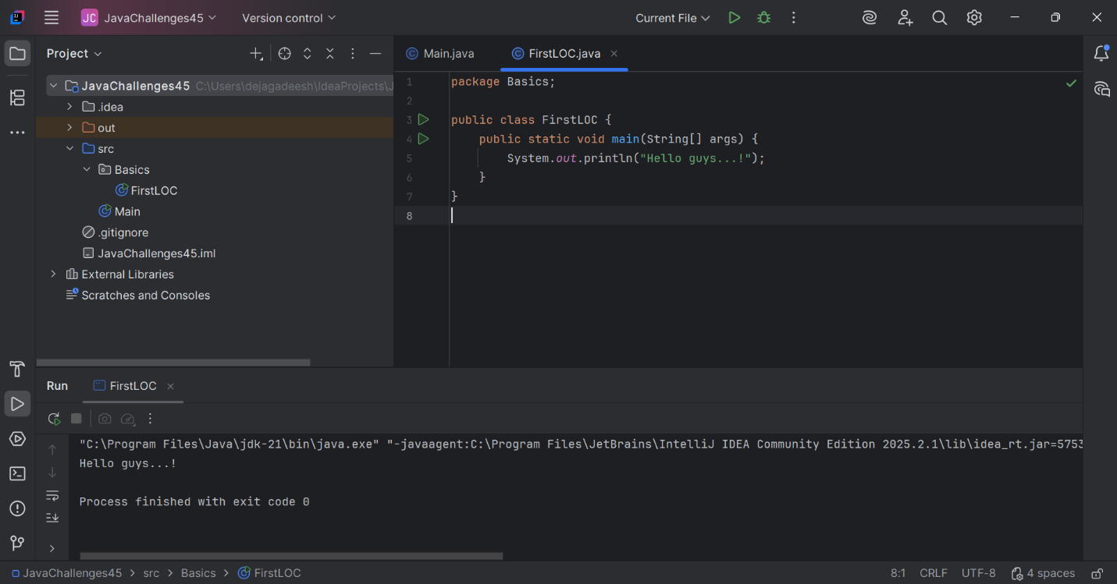

2) Currently ‘Git’ is not displayed in the Menu

6) Create a new Repository in GitHub account   
](https://github.com/Djagadeesh4513/JavaChallenges45.git)

**Pushing Code into GitHub after new changes/additions are made.**

a) Add new class or file. **Click on ‘Cancel’ button from pop-up 🡪 ‘Add File to Git’**

b) Add new class or file**. Click on ‘Add’ button from pop-up 🡪 ‘Add File to Git’**

